**Group Project Assignment: How Cauvery basin values its environment quality relative to agriculture?**

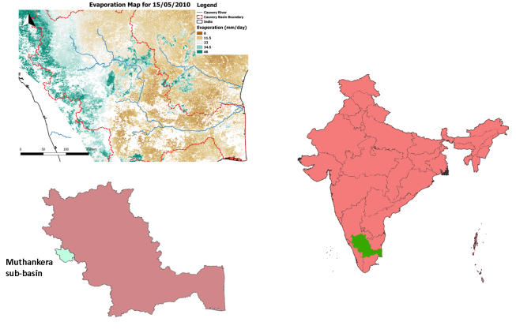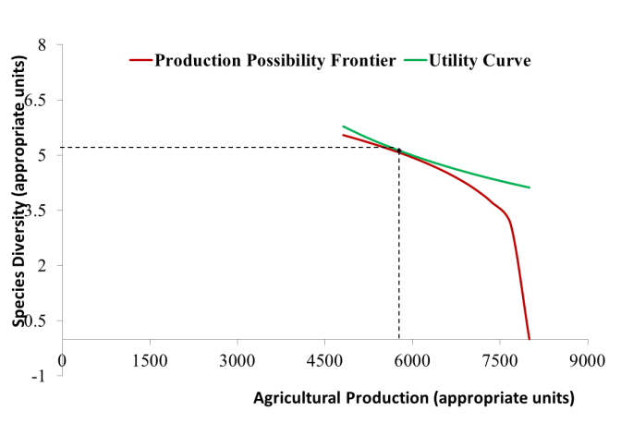

Form groups of 1-3 to build a real world, low dimensional, agricultural income-environmental quality model, by addressing the following tasks:

* Build a simplified TOPOFLEX model of river flow for Muthunkera sub-basin of Cauvery river basin using provided land use and hydroclimatic data
* Link changing irrigated area to degrading water quality based on the assumption that irrigated agriculture implies intensive agriculture with heavy use of fertilizers
* Create Production Possibility Frontier (PPF) of the sub-basin of producing agriculture income and ecosystem services: by simulating trade offs between income from agriculture income based on area under irrigation, consequent water quantity and quality and how water quantity/quality is related to delivery of ecosystem services (e.g. fish species richness).
* Conceptualize utility derived by sub-basin communities in terms of its preference for consumption from agricultural income relative to the ‘consumption’ of ecosystem services
* Plot the current state of affairs on the PPF and interpret what it means for the preference structure of communities (i.e. how they value environment relative to agricultural income) as revealed by the status-quo
* Discuss possible interventions to improve environmental quality based on the above.

The presentations for the group project are due in week 4.9, while the project report addressing the tasks above are due on the day of the written exam.